Lab Exercise 1: Demonstrate Nested For Loop
Objective:
To understand the use of nested for loops in C.
Problem Statement:
Write a C program using nested for loops to print a right-angled triangle pattern of stars (*).
Algorithm:
- Start
- Read the number of rows n
- For each row i from 1 to n:
a. For each column j from 1 to i:
i. Print *
b. Move to the next line
- Stop
Program Code:
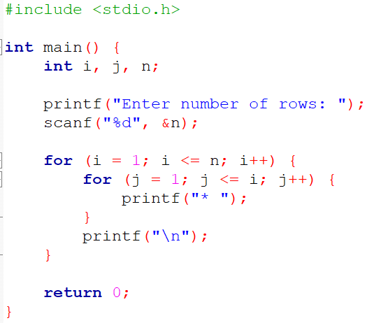
Sample Output:
Enter number of rows: 4
*
* *
* * *
* * * *

Lab Exercise 2: Generate Fibonacci Series
Objective: To write a C program that generates and displays the Fibonacci series up to n terms.
Problem Statement: Write a C program to print the Fibonacci series for the first n terms, where the user enters n.
Algorithm:
- Start
- Read the number of terms n
- Initialize first = 0, second = 1
- Repeat until i < n:
- a. Print first
- b. next = first + second
- c. first = second, second = next
- Stop
Program Code:
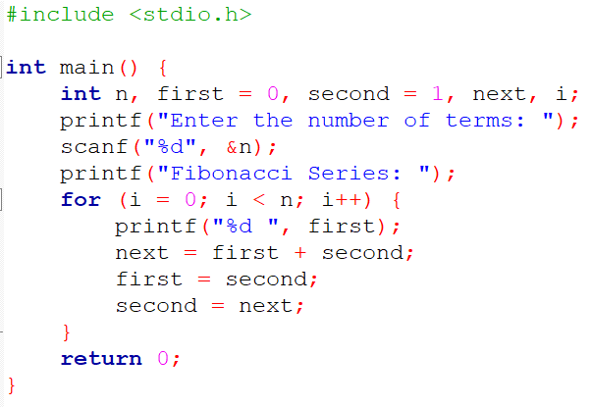Sample Output:
Enter the number of terms: 7
Fibonacci Series: 0 1 1 2 3 5 8

Lab Exercise 3: Find the Sum of Digits of a Number
Objective: To calculate the sum of digits of a given number.
Problem Statement:** Write a C program to find the sum of all digits of an integer entered by the user.
Algorithm:
- Start
- Read the number n
- Initialize sum = 0
- Repeat while n != 0:
- a. digit = n % 10
- b. sum = sum + digit
- c. n = n / 10
- Print sum
- Stop
Program Code:
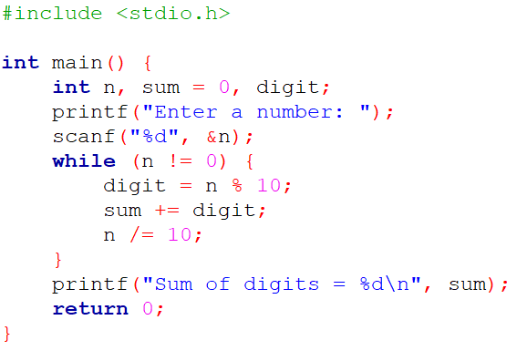Sample Output:
Enter a number: 1234
Sum of digits = 10

Lab Exercise 4: Print All Prime Numbers in a Given Range
Objective: To identify and print all prime numbers within a given range.
Problem Statement: Write a C program to display all prime numbers between two integers entered by the user.
Algorithm:
- Start
- Read low and high
- For each number i in [low, high]:
- a. Skip if i <= 1
- b. Check divisibility from 2 to √i
- c. If not divisible by any, print i
- Stop
Program Code:
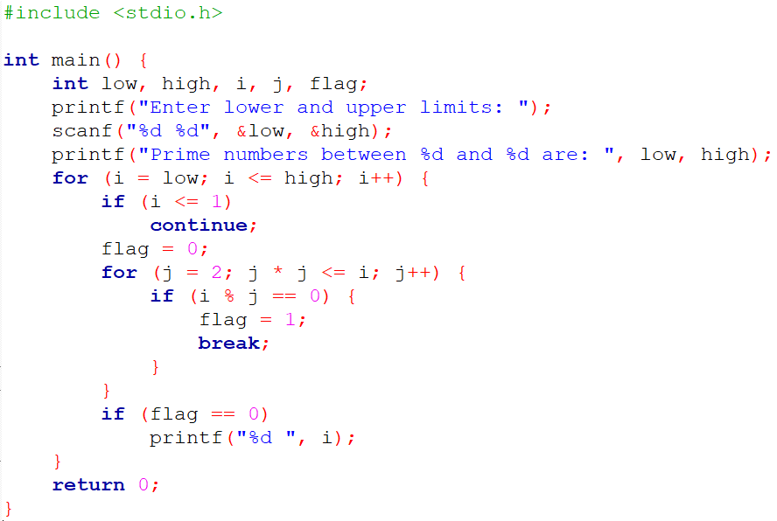Sample Output:
Enter lower and upper limits: 10 30
Prime numbers between 10 and 30 are: 11 13 17 19 23 29

Lab Exercise 5: Reverse a Given Number
Objective: To find and display the reverse of an integer.
Problem Statement: Write a C program to reverse the digits of an integer entered by the user.
Algorithm:
- Start
- Read n
- Initialize reversed = 0
- Repeat while n != 0:
- a. digit = n % 10
- b. reversed = reversed * 10 + digit
- c. n = n / 10
- Print reversed
- Stop
Program Code:
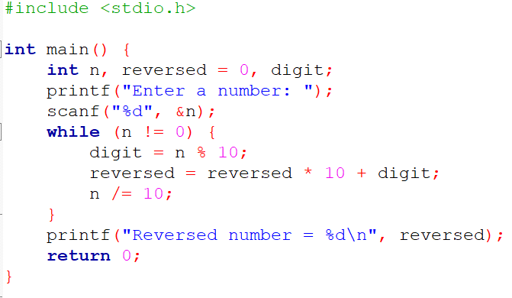Sample Output:
Enter a number: 12345
Reversed number = 54321

Lab Exercise 6: Check Whether a Number is Palindrome or Not
Objective: To determine whether a given number is a palindrome.
Problem Statement: Write a C program to check whether a number is palindrome or not.
Algorithm:
- Start
- Read the number n
- Store original = n
- Reverse the number
- If original == reversed → Palindrome
- Else → Not Palindrome
- Stop
Program Code:
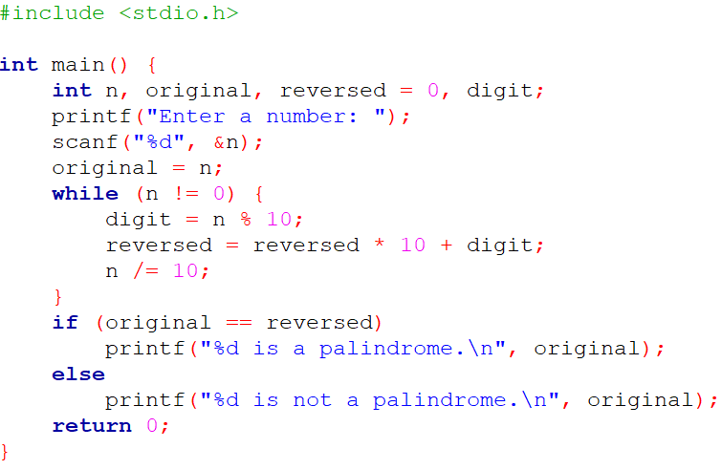Sample Output:
Enter a number: 1221
1221 is a palindrome.

